DCOMP320 DATA STRUCTURES AND ALGORITHMS
Individual Assignment: Stacks Implementation
An Object-Oriented, Unit-Tested Expression Evaluator
Built on a Stack with Exact Decimal Arithmetic

Course: DCOMP320 Data Structures and Algorithms
Institution: Limkokwing University of Creative Technology, Sierra Leone
GitHub repository: ________________________________________

CONTENTS
1. Introduction
2. Data Structures Used
3. Program Design
4. Testing and Results
5. Conclusion
6. References
1. INTRODUCTION
Every time a calculator, a spreadsheet or a programming language works out something like 10 - (2 + 3) * 4, it follows rules about which operation comes first. This assignment asks for a program that follows those rules using a stack. The program must read expressions from input.txt, evaluate each one, and write the results to output.txt in the same layout, keeping the separator lines (-----) exactly where they were.
This solution treats the assignment as a small piece of software engineering and not only as a script. The code is organised into four classes, each with one clear job (Stack, Tokenizer, Expression Evaluator and File Processor). Problems with an expression are reported through a custom exception, so that a bad line never stops the program. Numbers are held as Python Decimal values, so decimal arithmetic is exact (0.1 + 0.2 is exactly 0.3). Finally, 17 automated unit tests were written, so that every part of the program can be re-checked with one command after any change.
The program supports the operators +, -, * and /, brackets, decimals and negative numbers, with standard precedence. Section 2 explains the stack data structure and how it evaluates expressions. Section 3 describes the design. Section 4 reports the testing: 17 unit tests and 27 system tests that were checked against an independent calculator. Section 5 concludes.
2. DATA STRUCTURES USED
2.1 The stack as an abstract data type
A stack is a collection that follows the Last In, First Out (LIFO) rule: the item added most recently is the first one removed. A stack of plates is the usual picture, and only the top plate can be reached. As an abstract data type, a stack is defined by its operations and not by its inner workings:
Operation | Meaning | Time cost
push(item) | Add an item to the top | O(1)
pop() | Remove and return the top item | O(1)
peek() | Return the top item without removing it | O(1)
Is empty() | Check if it is full or empty | O(1)
size() | Number of items held | O(1)
Table 1: The stack interface
2.2 Implementation as a class
The Stack class stores its items in a Python list held in a private attribute (_items), so other code can only use the stack through its operations. This is called encapsulation, and it means the list could be replaced by another structure without changing the rest of the program. The top of the stack is the end of the list, because adding and removing at the end of a list takes constant time. pop and peek raise Index Error when the stack is empty, so a logic mistake is caught at once. The class also provides __len__, so len(stack) works, and repr, which prints the contents and is useful when debugging.
2.3 Evaluating expressions with two stacks
The evaluator uses two stacks at the same time, a method based on Dijkstra's shunting-yard algorithm. The value stack holds numbers and intermediate results. The operator stack holds operators and open brackets that are waiting for their turn. The expression is read from left to right, one token at a time, using these rules:
1. A number is pushed on the value stack.
2. An open bracket is pushed on the operator stack.
3. An operator first applies any operator already on top of the operator stack that has the same or higher precedence (each application pops two numbers, calculates, and pushes the result back). The new operator is then pushed.
4. A close bracket applies operators until the matching open bracket is on top, then removes that bracket.
5. At the end, any operators left are applied. The one remaining number on the value stack is the answer.
Table 2 follows the evaluation of the handout example (8 / 4) + 7 * 2 token by token. The table was produced by running the algorithm, not typed by hand. It ends with 16, which is the correct answer (see Section 4.5).
Step | Token | What happens | Value stack | Operator stack
1 | ( | push | [] | [(]
2 | 8 | push number | [8] | [(]
3 | / | push operator | [8] | [(, /]
4 | 4 | push number | [8, 4] | [(, /]
5 | ) | apply 8 / 4 = 2; discard '(' | [2] | []
6 | + | push operator | [2] | [+]
7 | 7 | push number | [2, 7] | [+]
8 | * | push operator | [2, 7] | [+, *]
9 | 2 | push number | [2, 7, 2] | [+, *]
10 | end | apply 7 * 2 = 14; apply 2 + 14 = 16 | [16] | [ ]
Table 2: Evaluating (8 / 4) + 7 * 2 with two stacks
2.4 Why Decimal and not float
Computers store ordinary floating-point numbers in binary, and many everyday decimals such as 0.1 cannot be stored exactly. This causes small errors that become visible in the result. Python's Decimal type works in base ten, so the numbers a person types are stored exactly. Table 3 compares the two, using the program itself to produce the Decimal column.
Expression | Ordinary float result | Decimal result (this program)
0.1 + 0.2 | 0.30000000000000004 | 0.3
0.1 * 3 | 0.30000000000000004 | 0.3
1.1 + 2.2 | 3.3000000000000003 | 3.3
19.99 * 3 | 59.97 | 59.97
Table 3: Floating-point versus Decimal results
The program prints results to at most four decimal places, so the exact value of a result such as 10 / 3 is shown as 3.3333.
2.5 Why stacks matter in computing
(*) The call stack: each function call pushes a return address, and each return pops it. This is what makes functions and recursion work.
(*) Undo and redo: an editor pushes every change on a stack, and undo pops the latest one.
(*) Browser back button: the most recently visited page is the first to be popped.
(*) Compilers and interpreters: stacks check that brackets match and evaluate or translate expressions, exactly the job done in this assignment.
(*) Backtracking and search: depth-first search, maze solving and puzzle solving all keep a stack of places still to explore.
(*) Virtual machines: several well-known virtual machines execute instructions that work on an operand stack.
3. PROGRAM DESIGN
3.1 Architecture and responsibilities
Each class has one job. This makes the code easier to read, test and change, because a change to how files are read cannot affect how expressions are calculated.
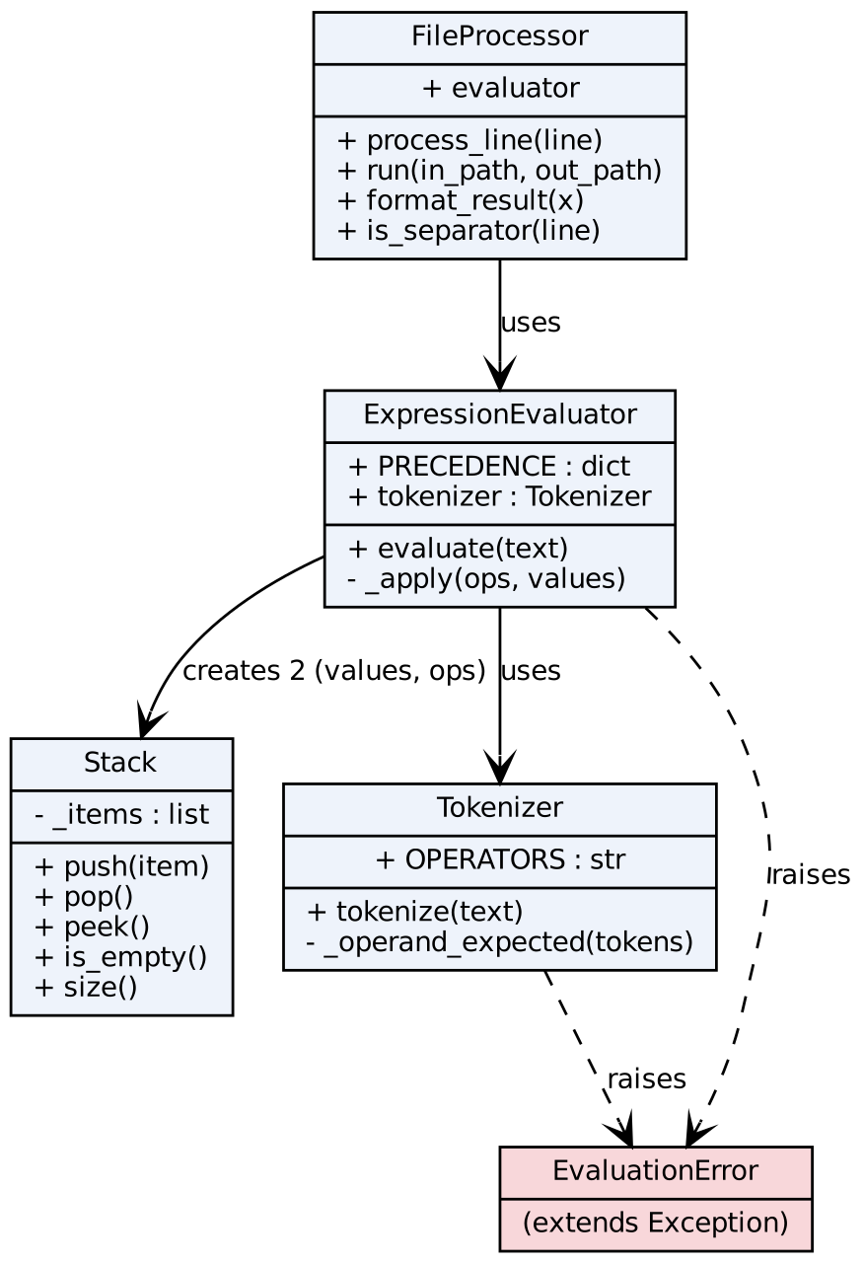
Figure 1: Class diagram
Class | Responsibility | Key methods
Stack | The LIFO data structure | push, pop, peek, empty, infix
Tokenizer | Turns text into Decimal numbers, operators and brackets; recorgnise negative signs; rejects invalid input | tokenize
Expression  Evaluator | Evaluates a token list using a value stack and an operator stack | evaluate, _apply
File Processor | Reads input.txt, copies separators, formats results, writes output.txt, counts answers and errors | run, process line, format_result, is_separator
Evaluation Error | Custom exception for every problem with an expression | (extends Exception)
Table 4: Classes and their responsibilities
3.2 Program flow
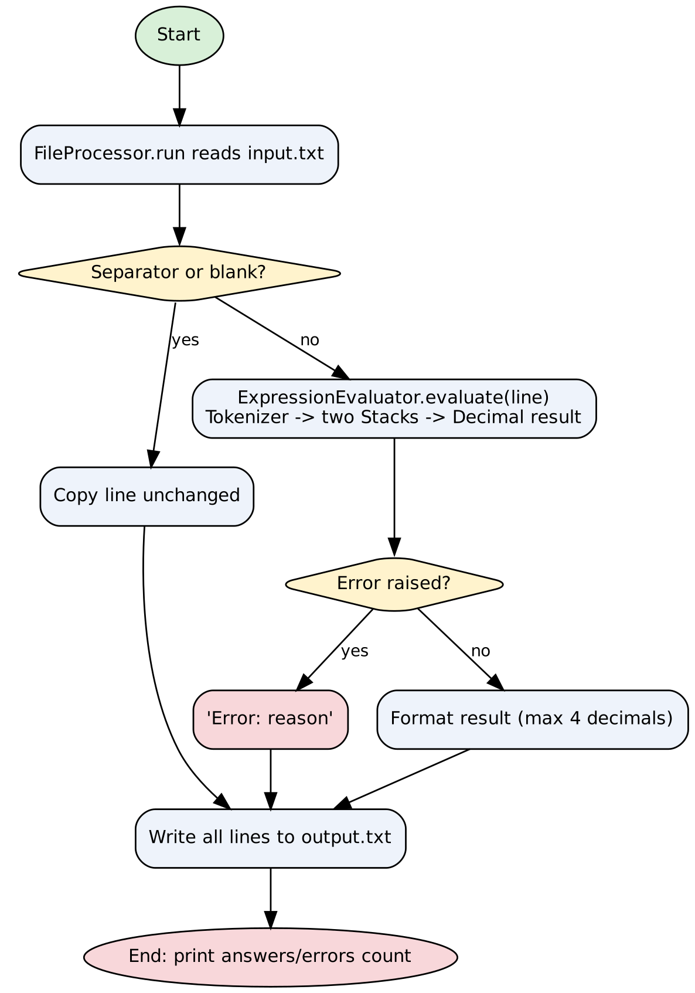
Figure 2: Flowchart of the program
3.3 Pseudocode
Expression Evaluator . evaluate
tokens = Tokenizer . tokenize(text)
if there are no tokens: raise Evaluation Error("empty expression")
values = new Stack; ops = new Stack
for each token:
if token is a number:
push it on values
else if token is "(" or a negative sign:
push it on ops
else if token is ")":
while top of ops is not "(":
apply the top operator
if ops is empty: raise Evaluation Error("mismatched parentheses")
pop and discard "("
else:
while top of ops is not "(" and has precedence >= token:
apply the top operator
push token on ops
while ops is not empty:
if top is "(": raise EvaluationError("mismatched parentheses")
apply the top operator
if values does not hold exactly one number: raise EvaluationError("malformed expression")
return values.pop()

FileProcessor.run
lines = all lines of input.txt
for each line:
if separator or blank:
result = the line itself
else:
try: result = format(evaluate(line))
on EvaluationError: result = "Error: " + message
write all results to output.txt
return (number of answers, number of error lines)

3.4 Design decisions
~ Custom exception. Every problem with an expression raises Evaluation Error with a plain message. File Processor catches it and writes the message on that line, so one bad line never stops the run.
~ Exact decimals. Numbers are Decimal values with 28 digits of precision, and results are rounded to four places only when printed.
~ Negative numbers. A minus sign at the start, after an open bracket or after an operator is a negative sign, not a subtraction.
~ Left-to-right order. Operators of equal precedence are applied in the order they appear, so 100 / 4 / 5 is 5.
~ Testability. Because evaluation is separate from file handling, the evaluator can be tested directly with a single line of text, which is what the unit tests do.
~ No eval(). Python's eval() would not use a stack and can run harmful code, so it is not used.
3.5 Error handling
Problem | Example | Message in output.txt
Division by zero | 6 / (2 - 2) | Error: division by zero
Missing or extra bracket | ((2 + 3) | Error: mismatched parentheses
Operator without a number | * 5 | Error: malformed expression
Operator not supported | 2 ** 3 | Error: malformed expression
Number with two points | 1.2.3 + 4 | Error: invalid number '1.2.3'
Unknown character | abc | Error: invalid character 'a'
Table 5: Errors the program detects
3.6 Extra features
• 17 automated unit tests (test_evaluator.py), run with python -m unittest test_evaluator -v.
• Exact decimal arithmetic.
• A summary line when the program finishes, for example: Done! 20 answers and 7 error lines written to output.txt.
• Custom file names on the command line, and a clear message if input.txt is missing.
3.7 Efficiency
Each token is pushed and popped at most once, and every stack operation is O(1), so an expression with n tokens is evaluated in O(n) time with O(n) extra space.
4. TESTING AND RESULTS
4.1 Two layers of testing
Unit tests check small pieces of the program in isolation, and they can be repeated at any time. System tests run the whole program on a realistic input file and check the output file. Both were used. Every expected value in the system tests was worked out by a second, independent method: a short recursive-descent calculator that uses exact fractions and no stacks.
4.2 Unit tests
Table 6 lists the 17 unit tests in test_evaluator.py. All 17 passed (Ran 17 tests, OK).
# | Test class | Test | What it proves | Result
1 | TestStack | test_push_pop_order | Items come off in the reverse order they were pushed | Pass
2 | TestStack | test_peek_does_not_remove | peek returns the top item and leaves the size unchanged | Pass
3 | TestStack | test_empty_errors | pop and peek on an empty stack raise IndexError | Pass
4 | TestEvaluator | test_handout_examples | The three handout examples give 13, 16 and -10 | Pass
5 | TestEvaluator | test_left_to_right | 100 / 4 / 5 gives 5 and 10 - 4 - 3 gives 3 | Pass
6 | TestEvaluator | test_brackets | ((2 + 3) * (4 - 1)) / 5 gives 3 | Pass
7 | TestEvaluator | test_negatives | -5 + 12, 2 * -3 and -(2 + 3) * 2 work | Pass
8 | TestEvaluator | test_decimals_exact | 0.1 + 0.2 is exactly 0.3; 7 / 2 is 3.5 | Pass
9 | TestEvaluator | test_errors | Six kinds of bad input give the right error message | Pass
10 | TestEvaluator | test_separator_and_blank_kept | Separator and blank lines pass through unchanged | Pass
11 | TestMoreCases | test_whitespace_ignored | Extra spaces around an expression do not matter | Pass
12 | TestMoreCases | test_nested_brackets | Deeply nested brackets give 16 | Pass
13 | TestMoreCases | test_big_numbers | 1000000 * 1000000 prints in full | Pass
14 | TestMoreCases | test_rounding_to_four_places | 22 / 7 gives 3.1429; 1/3 three times gives 1 | Pass
15 | TestMoreCases | test_invalid_number | 1.2.3 is reported as an invalid number | Pass
16 | TestMoreCases | test_evaluator_raises_error_type | Division by zero raises EvaluationError | Pass
17 | TestFiles | test_round_trip_keeps_separators | A temporary input file gives the right output file, separators kept, counts correct | Pass
Table 6: Unit tests
4.3 System tests
The file input.txt holds 27 expressions: the three handout examples, 17 further expressions (decimals, precision, brackets, negatives, rounding) and 7 error cases. The program's output was compared with the independent calculator. All 27 agreed.
# | Test expression | Expected | Program output | Result
1 | 3 + 5 * 2 | 13 | 13 | Pass
2 | (8 / 4) + 7 * 2 | 16 | 16 | Pass
3 | 10 - (2 + 3) * 4 | -10 | -10 | Pass
4 | 0.1 + 0.2 | 0.3 | 0.3 | Pass
5 | 0.1 * 3 | 0.3 | 0.3 | Pass
6 | 1 / 3 + 1 / 3 + 1 / 3 | 1 | 1 | Pass
7 | 2.5 * 4 | 10 | 10 | Pass
8 | 19.99 * 3 | 59.97 | 59.97 | Pass
9 | 100 - 0.01 | 99.99 | 99.99 | Pass
10 | (1.5 + 2.5) * (3.5 - 1.5) | 8 | 8 | Pass
11 | -3.2 + 5.2 | 2 | 2 | Pass
12 | 7 / 8 | 0.875 | 0.875 | Pass
13 | 22 / 7 | 3.1429 | 3.1429 | Pass
14 | 2 / 3 | 0.6667 | 0.6667 | Pass
15 | 1.005 + 1.005 | 2.01 | 2.01 | Pass
16 | 3.14159 * 2 | 6.2832 | 6.2832 | Pass
17 | 10 - 3 - 2 - 1 | 4 | 4 | Pass
18 | 2 * (3 + (4 - (5 - 6))) | 16 | 16 | Pass
19 | -(-(-4)) | -4 | -4 | Pass
20 | 9 / 3 / 3 | 1 | 1 | Pass
21 | 4 / 0.0 | Error: division by zero | Error: division by zero | Pass
22 | ((2 + 3) | Error: mismatched parentheses | Error: mismatched parentheses | Pass
23 | 1.2.3 + 4 | Error: invalid number '1.2.3' | Error: invalid number '1.2.3' | Pass
24 | abc | Error: invalid character 'a' | Error: invalid character 'a' | Pass
25 | 2 ** 3 | Error: malformed expression | Error: malformed expression | Pass
26 | * 5 | Error: malformed expression | Error: malformed expression | Pass
27 | 6 / (2 - 2) | Error: division by zero | Error: division by zero | Pass
Table 7: System tests. 27 of 27 passed.
4.4 Discussion of the input and output files
The input file has 53 lines and the output file has 53 lines. Every expression line in the input has been replaced by its result in the output, and every separator line is in exactly the same position. Table 8 shows the first 17 lines of both files side by side.
Line | input.txt | output.txt
1 | 3 + 5 * 2 | 13
2 | ----- | -----
3 | (8 / 4) + 7 * 2 | 16
4 | ----- | -----
5 | 10 - (2 + 3) * 4 | -10
6 | ----- | -----
7 | 0.1 + 0.2 | 0.3
8 | ----- | -----
9 | 0.1 * 3 | 0.3
10 | ----- | -----
11 | 1 / 3 + 1 / 3 + 1 / 3 | 1
12 | ----- | -----
13 | 2.5 * 4 | 10
14 | ----- | -----
15 | 19.99 * 3 | 59.97
16 | ----- | -----
17 | 100 - 0.01 | 99.99
Table 8: First 17 lines of input.txt and output.txt
Whole-number results have no decimal point (13, not 13.0), and other results are shown to at most four decimal places (22 / 7 gives 3.1429). Error cases show a message on the same line, and the lines after them are still evaluated, which shows that one bad expression does not stop the run. When the program finishes it prints how many answers and how many error lines it wrote, which gives a quick check without opening the file.
4.5 A correction to the handout example
The handout gives the answer to (8 / 4) + 7 * 2 as 17. By hand, 8 / 4 = 2, 7 * 2 = 14, and 2 + 14 = 16. The correct answer is 16. The program, the unit tests and the independent calculator all give 16, so the handout figure appears to be a typing error. The other two handout answers (13 and -10) are correct.
4.6 Limitations
• Exponents, variables, functions and implicit multiplication such as 3(4) are not supported; the last is reported as a malformed expression.
• Scientific notation such as 1e3 is rejected as an invalid character.
• Results are rounded to four decimal places when printed.
4.7 How to repeat the tests
Run python stack_evaluator.py to regenerate output.txt, and python -m unittest test_evaluator -v to run the 17 unit tests. Both commands work from any folder that contains the files.

5. CONCLUSION
The program meets the requirements: a Stack class with push, pop and peek; evaluation of expressions with correct precedence and brackets using two stacks; and file input and output in the required format with the separator lines kept. It goes further with a class-based design, exact decimal arithmetic, safe error handling, and a suite of 17 unit tests. All 17 unit tests and all 27 system tests passed.
The main lessons were that a simple data structure can solve a problem that looks complicated, that testing against an independent method finds mistakes (it exposed the wrong answer in the handout), and that separating the program into small classes makes it much easier to test. Possible improvements are exponents, variables and functions, and a graphical calculator interface.
6. REFERENCES
1. Cormen, T. H., Leiserson, C. E., Rivest, R. L. and Stein, C. (2009). Introduction to Algorithms, 3rd edition. Cambridge, MA: MIT Press. (Section 10.1, Stacks and queues.)
2. Dijkstra, E. W. (1961). Algol 60 Translation: An Algol 60 Translator for the X1 and Making a Translator for Algol 60. Report MR 34/61. Amsterdam: Mathematisch Centrum.
3. Martin, R. C. (2008). Clean Code: A Handbook of Agile Software Craftsmanship. Upper Saddle River, NJ: Prentice Hall.
4. Python Software Foundation (2026). The Python Standard Library: decimal, Decimal fixed point and floating point arithmetic. https://docs.python.org/3/library/decimal.html (accessed October 2026).
5. Python Software Foundation (2026). The Python Standard Library: unittest, Unit testing framework. https://docs.python.org/3/library/unittest.html (accessed October 2026).
6. Python Software Foundation (2026). The Python Tutorial: Floating-Point Arithmetic, Issues and Limitations. https://docs.python.org/3/tutorial/floatingpoint.html (accessed October 2026).

